API Security Risk Analysis
Name: Mohdissa Fizza
Date: 30th April 2026
- Introduction
This report presents a security analysis of a public API (JSONPlaceholder). The objective is to identify common API security risks and recommend improvements using safe, read-only testing.
APIs are widely used in modern SaaS applications, and insecure APIs can lead to data breaches, unauthorized access, and service abuse.
This analysis follows ethical guidelines and does not involve exploitation or harmful testing.
- Scope
API: JSONPlaceholder
Method: Read-only testing
Tool: Postman
This analysis was conducted in accordance with ethical guidelines and limited to publicly available APIs.
- API Endpoints Tested
The following endpoints were tested during the analysis:
- /users
- /posts
- /comments

- Methodology
The API was tested by sending GET requests using Postman. The API documentation was reviewed to understand endpoint behavior.
All testing was conducted in a controlled and ethical manner without attempting to exploit vulnerabilities.
Responses, headers, and returned data were analyzed to identify potential security risks. The testing focused on:
- Authentication and authorization mechanisms
- Data exposure in API responses
- Presence of security headers
- Rate limiting controls
- Screenshots and Evidence
Only a portion of the API response is shown for readability.

5.1 Users Endpoint Response
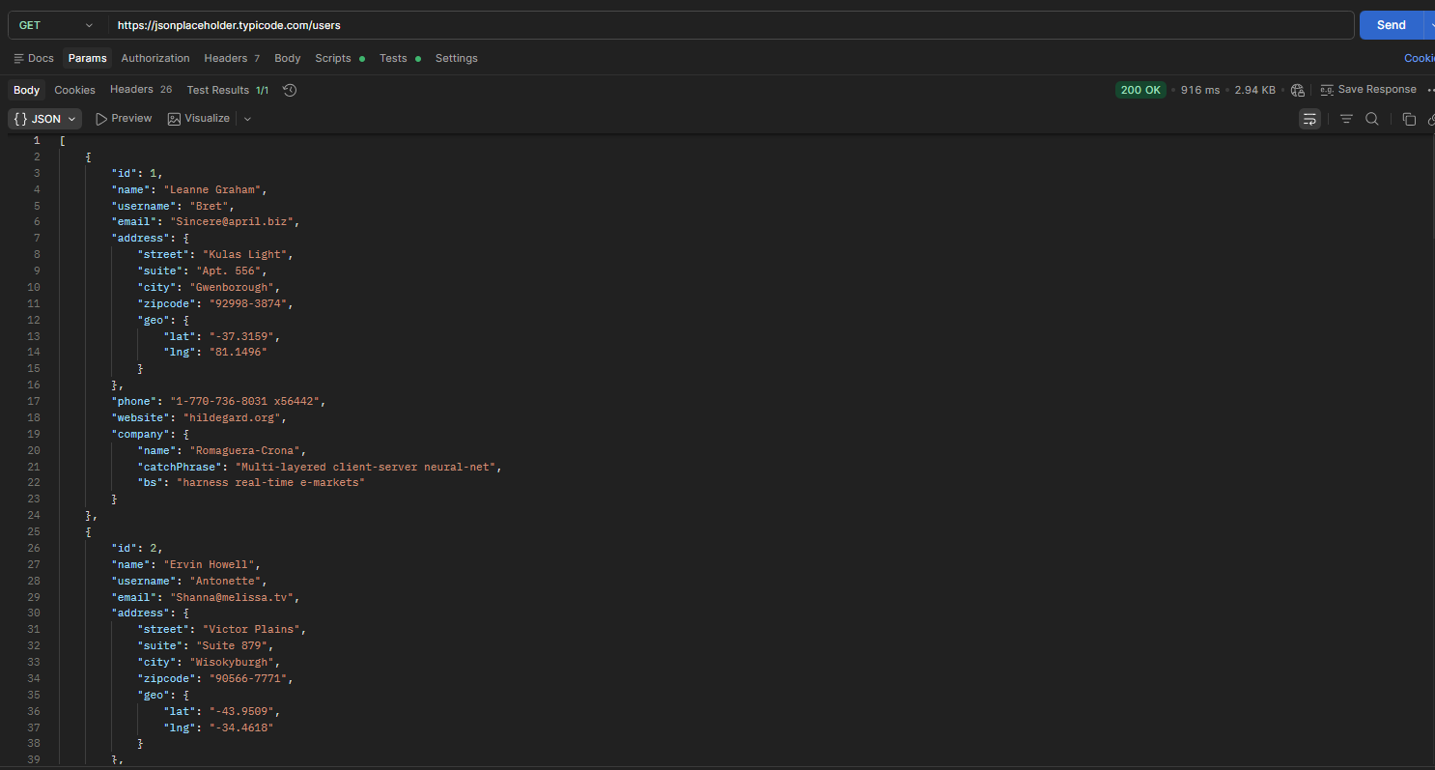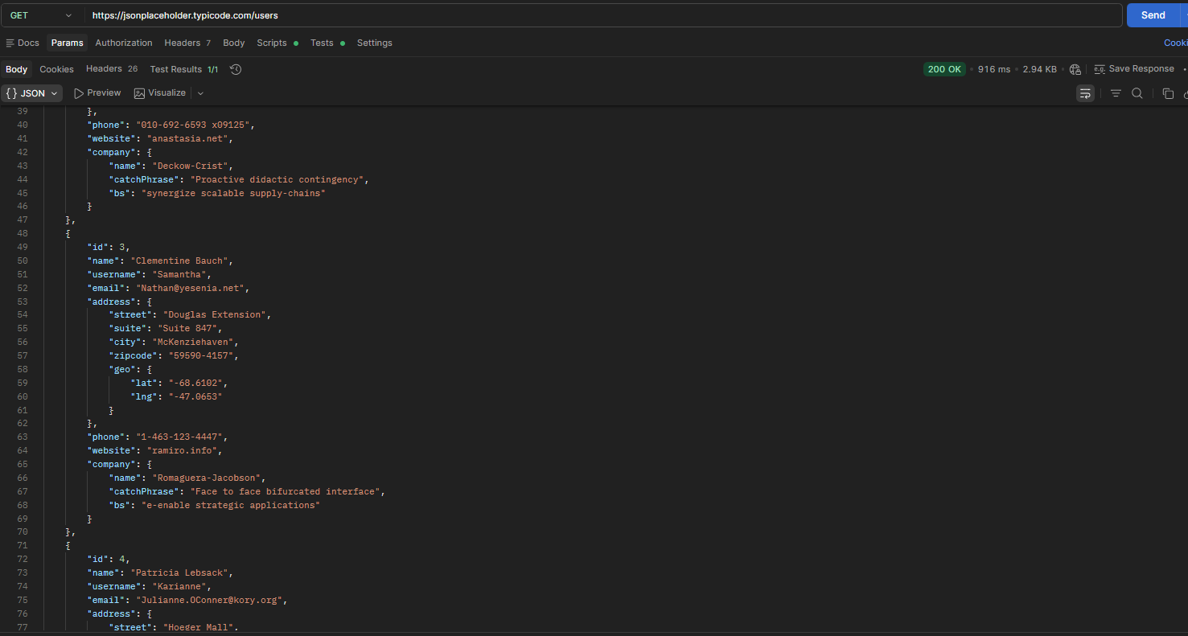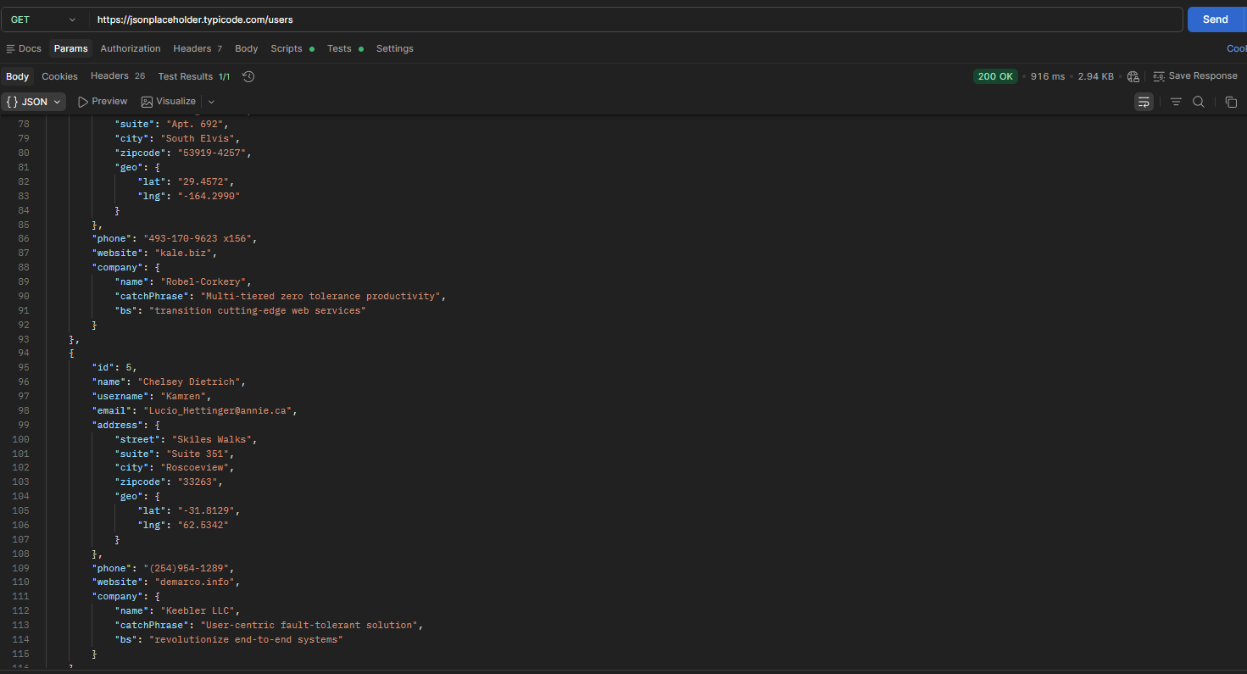
Figure 1: Users endpoint showing publicly accessible user data.
  - Users Headers
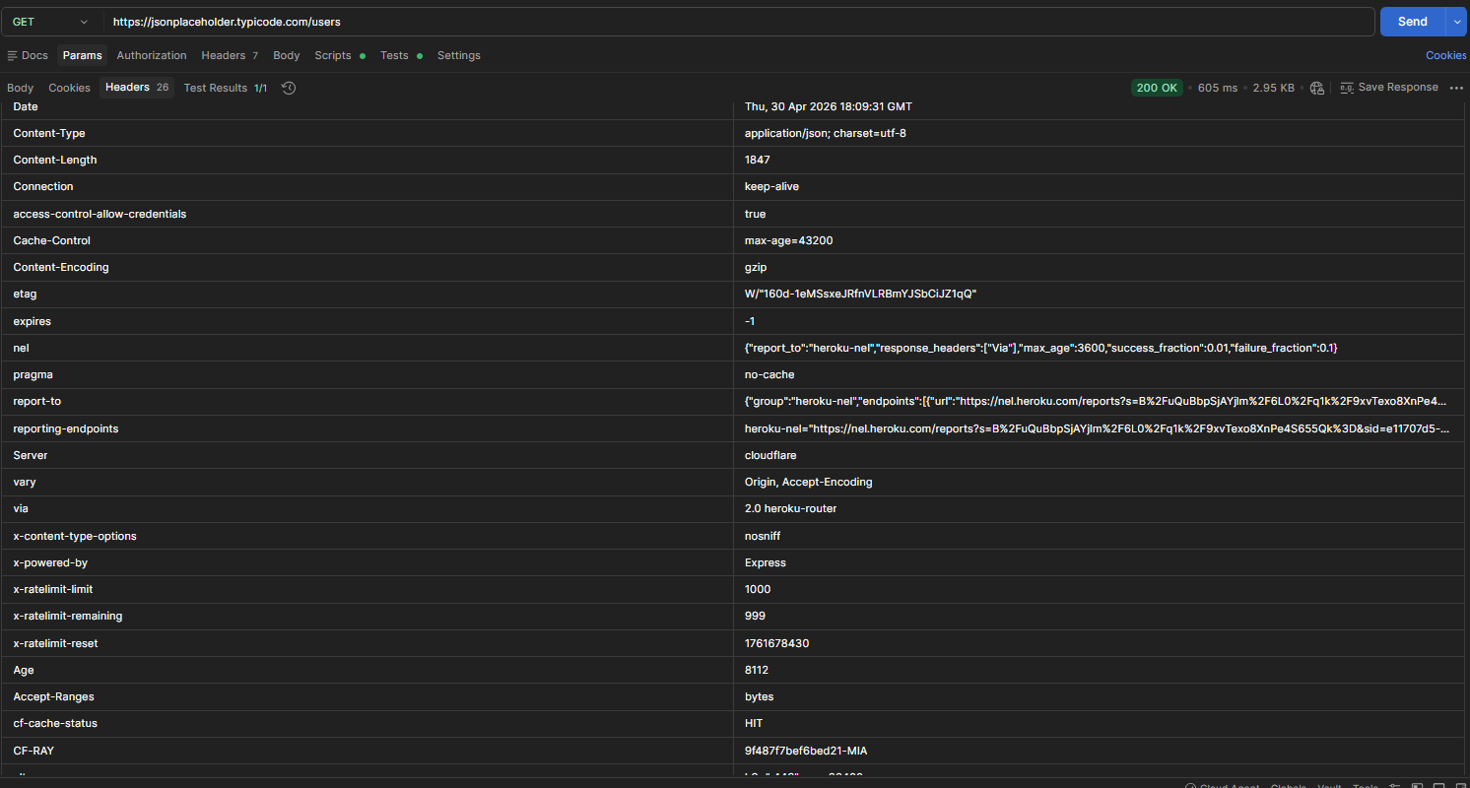
Figure 2: Headers showing missing security controls.
5.3 Posts Endpoint Response
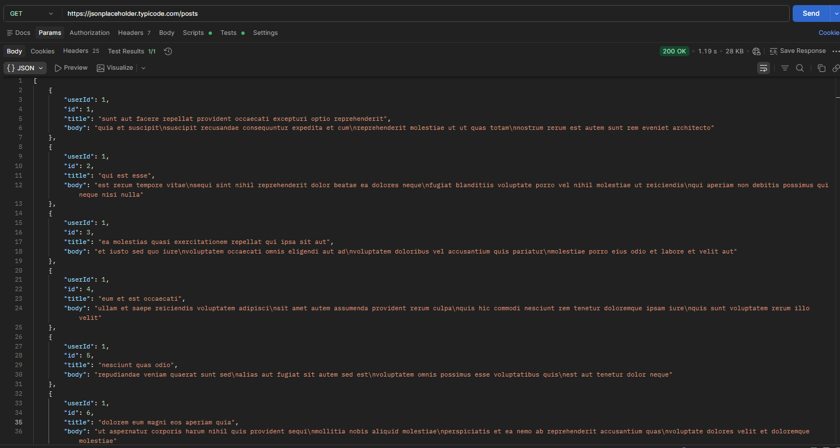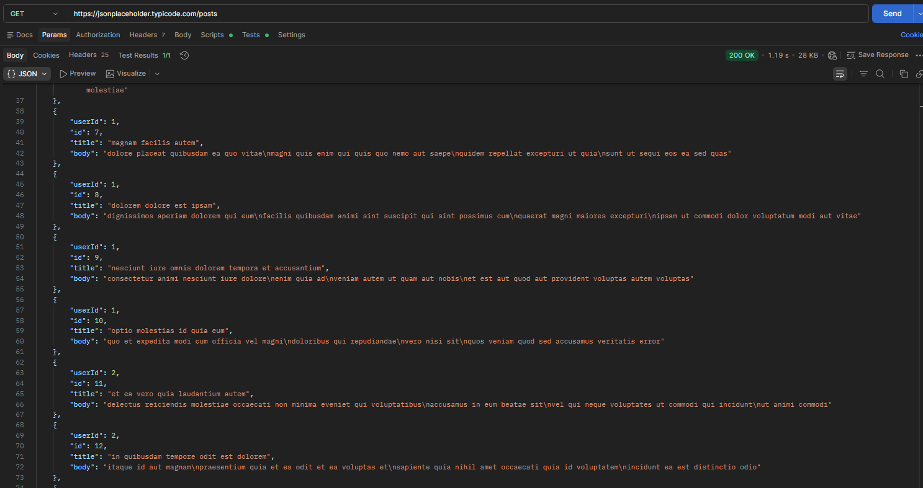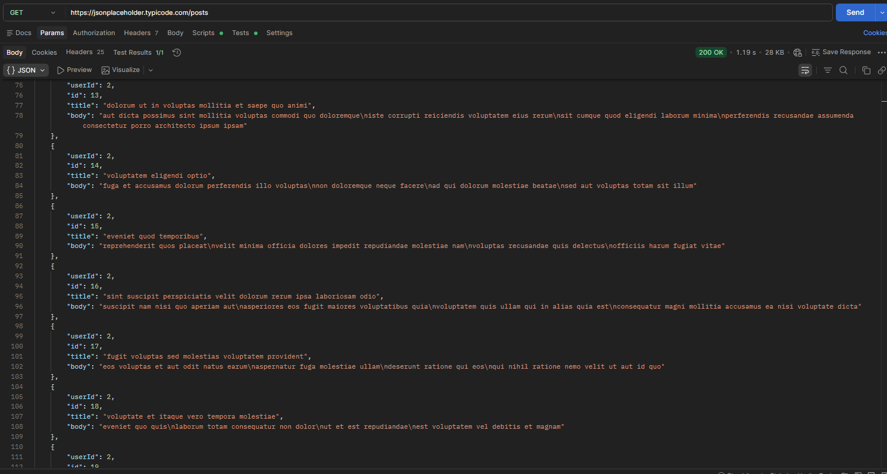
Figure 3: Posts endpoint response.

5.4 Posts Headers
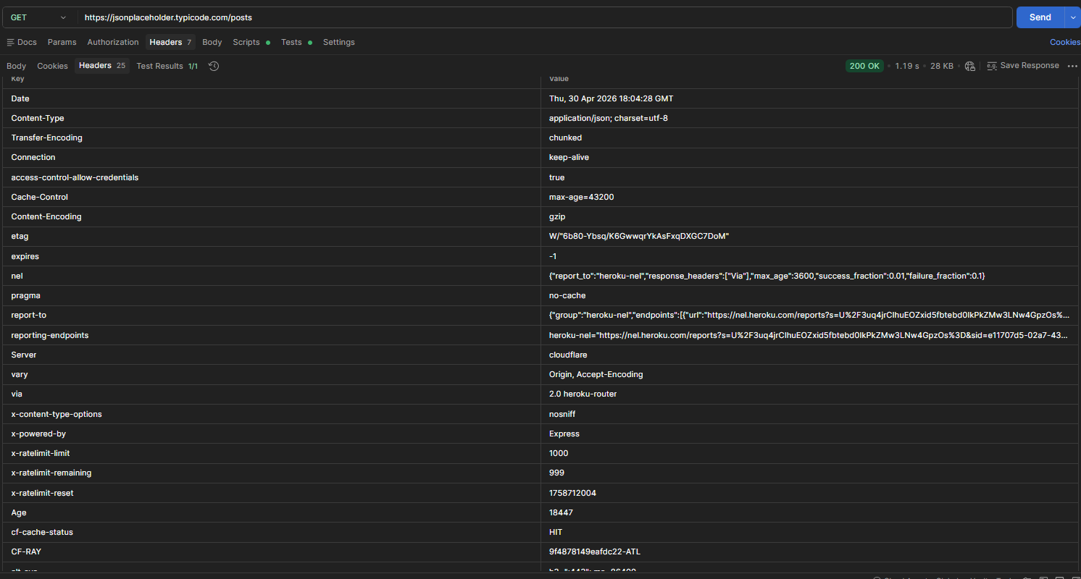
Figure 4: Headers for posts endpoint.

5.5 Comments Endpoint Response
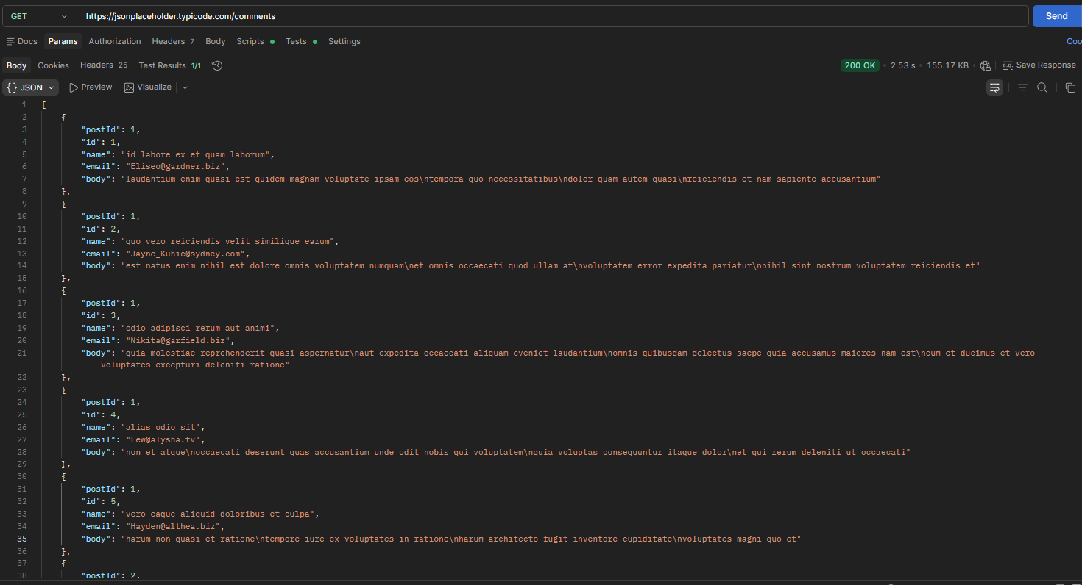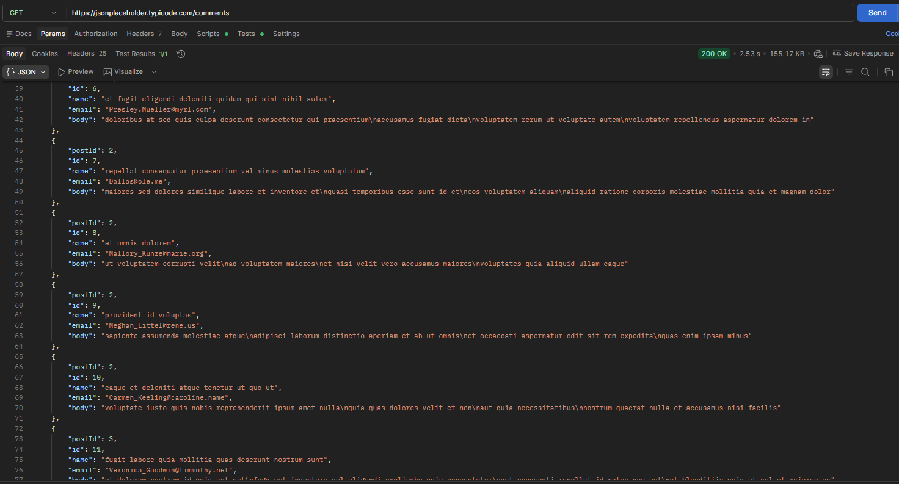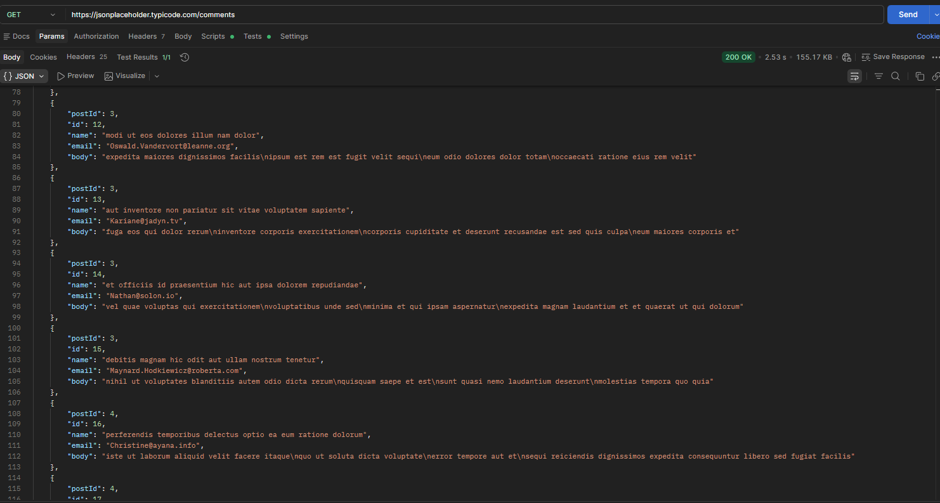
Figure 5: Comments endpoint response.

5.6 Comments Headers
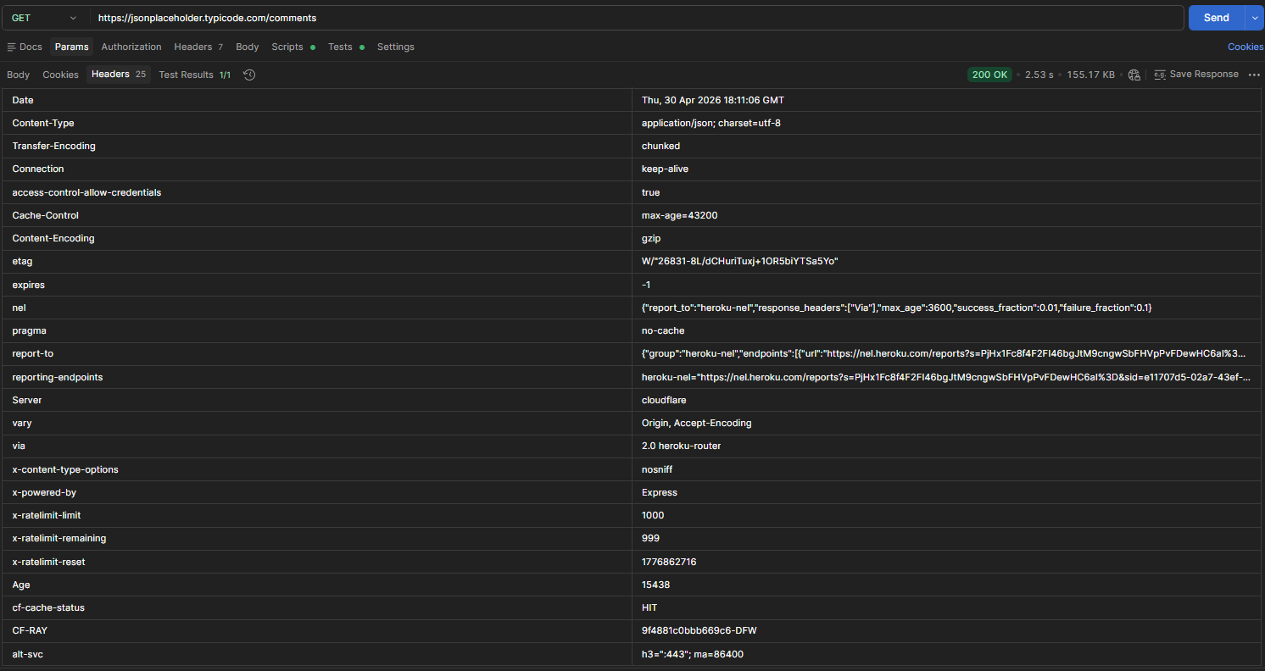
Figure 6: Headers for comments endpoint.
- Identified Security Risks

6.1 No Authentication (High Risk)
The API allows access to endpoints without requiring any authentication such as login credentials or tokens.
Business Impact:
Unauthorized users can access sensitive data, which may lead to data breaches, privacy violations, and loss of customer trust.
Recommendation:
Implement authentication mechanisms such as JWT tokens or API keys.

6.2 No Authorization (High Risk)
The API does not enforce user-level access control, allowing access to all user data.
Business Impact:
Users may access data belonging to other users, resulting in serious data leakage and compliance issues.
Recommendation:
Implement role-based access control (RBAC) and validate user permissions.
6.3 Excessive Data Exposure (Medium Risk)
The API returns full user details such as email and address even when not required.
Business Impact:
Exposing unnecessary data increases the risk of misuse, identity theft, and social engineering attacks.
Recommendation:
Limit API responses to only necessary fields and use data filtering.
6.4 No Rate Limiting (Medium Risk)
The API does not limit the number of requests that can be made.
Business Impact:
Attackers can overload the system with repeated requests, potentially causing service disruption.
Recommendation:
Implement rate limiting controls (e.g., requests per minute).
6.5 Missing Security Headers (Low Risk)
The API responses lack important security headers.
Business Impact:
This increases the attack surface and may expose the system to common web-based attacks.
Recommendation:
Add headers such as Content-Security-Policy and Strict-Transport-Security.
- Risk Summary Table
Risk | Severity
No Authentication | High
No Authorization | High
Excessive Data Exposure | Medium
No Rate Limiting | Medium
Missing Security Headers | Low
- Conclusion
The analysis identified critical security weaknesses, particularly in authentication and access control. While this API is intended for testing, similar vulnerabilities in real-world applications could result in serious data breaches and service abuse.
Implementing proper security controls such as authentication, authorization, and rate limiting is essential to ensure data protection and system reliability.

